**Sri ASNM GOVT. COLLEGE (A), PALAKOL**

**EARTH DAY – APRIL 22-2022**

Earth Day is an annual event on April 22 to demonstrate support for [environmental protection](https://en.wikipedia.org/wiki/Environmental_protection). First held on April 22, 1970, it now includes a wide range of events coordinated globally by Earth Day.

**DEPARTMENT OF BOTANY CONDUCTING AWARENESS PROGRAMME**

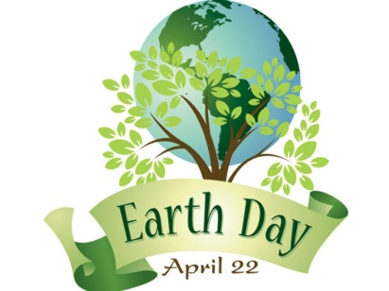

**THEME**

**“INVEST IN OUR PLANET”**

This is the moment to change it all - the business climate, the political climate, and how we take action on climate. Now is the time for the unstoppable courage to preserve and protect our health, our families, and our livelihoods.

worldwide campaign to remove billions of pieces of trash from neighborhoods, beaches, rivers, lakes, trails, and parks reducing waste and plastic pollution, improving habitats, and preventing harm to wildlife and humans.

The time is now to create a generation of citizens, workers, students, and leaders ready for climate change. We need public understanding of how to stop climate change and environmental harm

**“SAVE SOIL”**

**LECTURERS PRINCIPAL**

